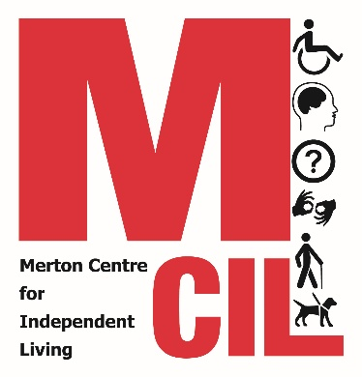
Complaints Form

This form should be returned to:
Advice Quality Manager
Merton CIL, Vestry Hall, 336 London Road
Mitcham, CR4 3UD
Or info@mertoncil.org.uk

You do not have to give your name and address, but we will not be able to contact you without your details.

Name:

Address:

Phone number:

Email:

Please use the space below to provide information about the service or event you are complaining about. Please provide as much information as possible to help us consider all the facts and respond quickly.

Signing this document means that you understand that a Merton CIL Senior Manager or Trustee will access your case file, contact you about the complaint and keep a log of action undertaken to try to resolve your complaint.

Signature:

Print name:

Date:

