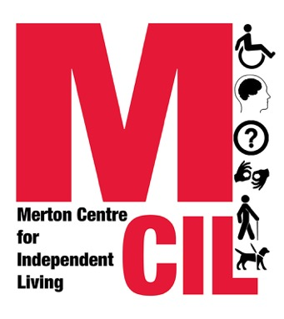
Referral to Merton CIL
This form is for the use of professionals who would like to refer someone to Merton CIL’s information and advice or speaking up service. People who want to self-refer should email or call us directly.

Please return the form via email to: info@mertoncil.org.uk

All information on this form is deemed to be confidential.
Information about the person being referred:
Name:

Date of birth:
Gender: | Female:  Male:  Non-binary:  Transgender:  If Other, please state:
Address:

Contact Details: | Phone  Email  Preferred method of contact:
Please confirm that the person you are referring is Deaf or Disabled and lives in the London Borough of Merton | If No, we will not be able to accept your referral.
Details of any disability access needs e.g. BSL, easy read etc.
Consent - Please confirm that the person has given you permission to share their details

Risk assessment - we are committed to keeping staff and service users safe. Are there any potential risks relating to the service user? Any there any risk reducing actions that you would advise us to take?

Information about the person making the referral

Name of person referring:

Position:

Organisation:

Contact Details: | Phone:  Email:
Relationship with the person referred:

Where did you hear about Merton CIL?

Needs of the person being referred
Read more about our Information & Advice service and our Speaking Up service to be sure that we can help the individual you are referring
Please also see further information about making a referral here.

Which service are you referring to? Please tick all that are relevant:
Information & Advice  **Current waiting time for a first appt is 8+ weeks. Please inform the people you are referring of this and ask them to request a deadline extension where necessary** | Benefits:  Concessionary Travel:  Social Care:  Housing – we are open to enquiries from people wishing to get on Merton’s housing register or wishing to improve their medical priority for housing. We are also open to aids & adaptations cases and people wishing to make an application for a Disabled Facilities Grant. We are not open to any other housing enquiries (last checked Sep 2024).
Speaking Up - We are unable to accept any new Speaking Up referrals due to capacity. We will be reviewing the situation in late May 2026. | Health:  Access barriers:  Isolation & Loneliness:

Reason for the referral (please give as much information as possible):

Information & Advice | Add details of support needed here. Leave blank if no support needed.
Speaking Up We are unable to accept any new Speaking Up referrals due to capacity. We will be reviewing the situation in late May 2026. | Add details of support needed here. Leave blank if no support needed.

Name & signature of referrer:

Date:

Electronic signatures are accepted.

