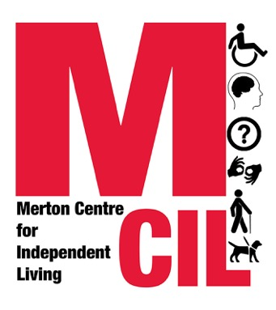

Referral to Merton CIL’s Information and Advice Service
This form is for the use of professionals who would like to refer someone to Merton CIL’s information and advice service. People who want to self-refer should email or call us directly.

Please return the form via email to: info@mertoncil.org.uk

Or post it to: Merton CIL, Vestry Hall, 336 London Road, Mitcham CR4 3UD

Contact number: 0203 397 3119

All information on this form is deemed to be confidential
Information about the person being referred

Name:

Date of birth: / /

Gender: Female [ ] Male [ ] Non-binary [ ] Transgender [ ] Other [ ]
If Other, please state:

Address:

Phone:

Email:

Preferred method of contact: Email [ ] Letter [ ] Telephone [ ]
Text [ ] Other [ ] If Other, please state:

Please confirm that the person you are referring is deaf or disabled and lives in the London Borough of Merton.

Yes [ ] No [ ] If No, we will not be able to accept your referral.

Please detail below any disability access needs we should take into account e.g. BSL, easyread etc.

Please confirm that the person has given you permission to share their details

Yes [ ]

Risk assessment

We are committed to keeping staff and service users safe. Are there any potential risks relating to the service user? Any there any risk reducing actions that you would advise us to take?

Information about the person making the referral

Name of person referring:

Position:

Organisation:

Address:

Phone:

Email:

Relationship with the person referred:

Where did you hear about Merton CIL?

Information and Advice needs of the person being referred

Please tick all that are relevant, but please be aware and inform the person being referred that we may be able to work on one issue only at the same time.

Welfare Benefits [ ]

Community Care (social care) [ ]

Concessionary Travel (Freedom Pass, Blue Badge etc) [ ]

Grant applications [ ]

Health [ ]

Housing [ ] We are closed to housing cases - with the exception of aids and adaptations (which includes Disabled Facilities Grant applications) - until further notice. The situation will be reviewed in April 2023.

Please look at our website before making the referral to see whether the advice need is something we can help with. Please see: https://www.mertoncil.org.uk/services/information-and-advice-service/

Please be aware that we normally operate a waiting list for all enquiries. Waiting times will vary throughout the year and can be anything from 2-12 weeks. We will always start working on a new case as soon as we have the capacity to do so. If there is an external deadline which we cannot meet (e.g. for the return of a benefit form), we will normally ask the service user to request an extension. From January 2023, our average waiting time for a first appointment is 8+ weeks.

If you do not provide sufficient information in the referral form, we will contact you and ask you to seek further information from the person you would like to refer.

If we do not accept your referral, we will let you know as soon as possible and we will ask you to inform the person you were hoping to refer.

Reason for the referral (please give as much information as possible):

Name and signature of person referring:
Electronic signatures are accepted.

Date:

