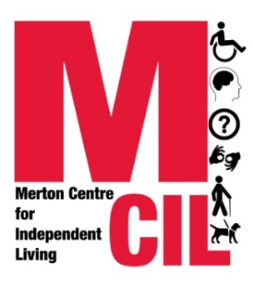**Monitoring form**

We are all different and need different things. We should all get the services that we need, whoever we are. You can help to ensure that this happens because monitoring shows us if certain people are not making the most of what we have to offer.

At Merton CIL we gather monitoring information to help us identify what does and does not work well in our organisation. It also helps us to check that other services and organisations are treating everyone fairly too. This helps us to provide better services to you.

**The information we gather is confidential and if you decide you no longer want us to know this information then we will delete it.**

**Gender**

Male  Female  Intersex  Non-binary  Prefer not to say 

If you prefer to use your own word(s), please write it/them below:

Is the gender you identify with the same as your gender registered at birth?

Yes ☐ No ☐ Prefer not to say ☐

**Age**

Under 17 18-24  25-34  35-44  45-54 55-64 

65-74  75-84  Over 85 Prefer not to say

**Disability**

A Disabled person A person with a long-term health condition

Parent of a Disabled child Carer of a Disabled Adult

A Non-Disabled person  Prefer not to say 

If you prefer to use your own word(s), please write it/them below:

**Disabled people, please tick as many boxes as you think are relevant to you:**

Autistic spectrum Cognitive disability Learning/Intellectual disability

Mental health issue Long-term ill health Visual impairment/sight loss

Neurodiverse Prefer not to say

If you prefer to use your own word(s), please write it/them below:

**Sexual Orientation**

Heterosexual Gay Lesbian Bisexual Asexual  Pansexual  Undecided  Prefer not to say 

If you prefer to use your own word(s), please write it/them below:

**Ethnicity**

Ethnicity is not the same as nationality, citizenship, or place of birth. It is the cultural group to which you perceive you belong. Please tick the appropriate box.

Asian or Asian British

Indian Pakistani Bangladeshi Chinese British Prefer not to say 

Any other Asian background, please write below:

Black or Black British

African Caribbean British Prefer not to say 

Any other Black, African or Caribbean background, please write below:

Mixed or multiple ethnic groups

White and Black Caribbean/African White and Asian  Prefer not to say 

Any other mixed or multiple ethnic background, please write below:

White

English Welsh Scottish Northern Irish Irish

British Gypsy or Irish Traveller European Prefer not to say

Any other White background, please write below:

Other ethnic group

Arab Other European Prefer not to say

Any other ethnic group, please write below:

**Religion**

No religion or belief Buddhist  Christian  Hindu 

Jewish Muslim  Sikh  Prefer not to say  If other religion or belief, please write below: