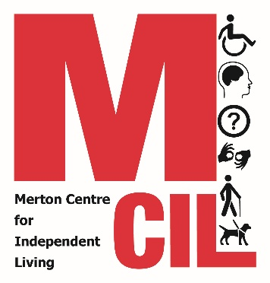
Monitoring form
We are all different and need different things. We should get the services that we need, whoever we are. The information that you share on this form helps us to make sure that all Disabled people are making the most of our services.

We ask for monitoring information to help us:
- Identify what does and does not work well in our organisation
- Ensure we are working with Disabled people from all communities
- To check that other organisations are treating everyone fairly
- To help us to provide a better service to you

The information we gather is confidential and if you decide you no longer want us to know this information then we will delete it.

Gender
Male  Female  Intersex  Non-binary  Prefer not to say 
If you prefer to use your own word(s), please write it/them below:

Is the gender you identify with the same as your gender registered at birth?
Yes ☐ No ☐ Prefer not to say ☐

Age
Under 17 18-24  25-34  35-44  45-54 55-64 
65-74  75-84  Over 85 Prefer not to say

Disability
A Disabled person A person with a long-term health condition
Parent of a Disabled child Carer of a Disabled adult
A non-disabled person  Prefer not to say 
If you prefer to use your own word(s), please write it/them below:

Disabled people, please tick all boxes relevant to you:
Autistic spectrum Cognitive disability Learning/Intellectual disability
Mental health condition Long-term ill health
Blind/Visual Impairment/Sight Loss
Neurodiverse Physical disability  Prefer not to say
If you prefer to use your own word(s), please write it/them below:

Sexual Orientation
Heterosexual Gay Lesbian Bisexual Asexual Pansexual Undecided Prefer not to say
If you prefer to use your own word(s), please write it/them below:

Ethnicity
Ethnicity is not the same as nationality, citizenship, or place of birth. It is the cultural group to which you perceive you belong. Please tick all boxes relevant to you.

Asian or Asian British
Indian Pakistani Bangladeshi Chinese British
Any other Asian background, please write below:

Black or Black British
African Caribbean British
Any other Black, African or Caribbean background, please write below:

Dual Heritage
Black Caribbean/African and White  Asian and White
Any other Dual Heritage background, please write below:

White
English Welsh Scottish Northern Irish Irish
British Gypsy or Irish Traveller European
Any other White background, please write below:

Other ethnic group
Arab Other European
Any other ethnic group, please write below:

Prefer not to say

Religion
No religion or belief Buddhist  Christian  Hindu 
Jewish Muslim  Sikh  Prefer not to say  If other religion or belief, please write below:

