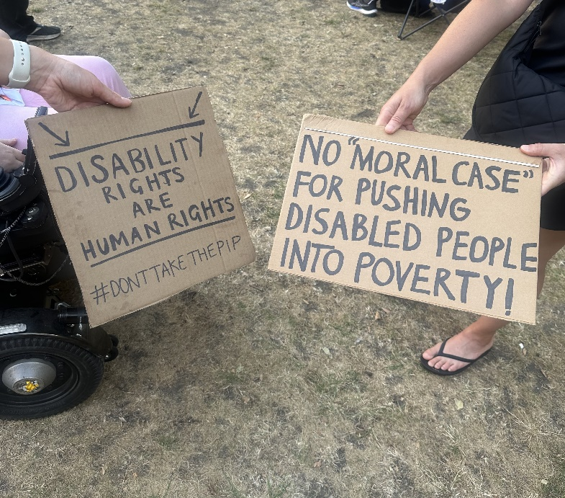

Dear Siobhain McDonagh MP for Mitcham and Morden,

I am one of your constituents. I am also a Disabled person, and a member of the local Deaf and Disabled People's Organisation called Merton Centre for Independent Living.

I was very disappointed to see that you voted for the Universal Credit and Personal Independence Payment Bill on 1 July. Disabled people already face multiple barriers in society. Please do not push us further into poverty. Please vote against the Bill at the third reading on 9 July.

ADD YOUR NAME AND ADDRESS HERE
